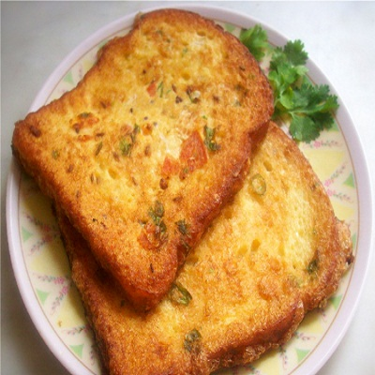

**Rye French Toast**

* 2 eggs
* 4 slices of bread
* About 1/8th cup of milk
* Sugar to taste
* Cooking Oil / Butter

Recipe Description:

1. Beat eggs in large bowl (bigger than the size of the bread)
2. Add about 1/8th packet of  milk to the mixture.
3. Add sugar to taste and beat again(use fork for simplicity) Add cinnamon (optional)
4. Spread the mixture throughout the bowl.
5. Meanwhile, add some butter to a large frying pan and heat on medium heat
6. Soak the rye bread in the mixture use a spatula to place the egg-soaked bread slices into the pan and let it cook
7. Then flip it over and cook for few minutes until golden
8. Serve with tomato sauce or your favourite sauce.

Enjoy your meal :)